Mechanical Walker

**PROBLEM STATEMENT**

Design a mechanical device that must navigate down a flight of stairs while carrying objects on it.

**Rules**

* Event will be conducted in two phases: prelims and finals.
* The stairs’ dimensions are 25cm X 10cmX 80 cm

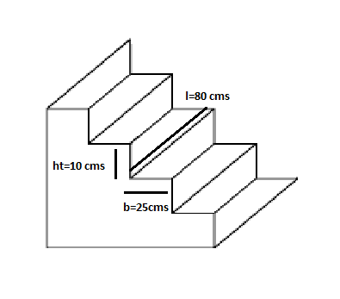

* The device should not make use of any electrical actuators.
* Only the gravitational potential energy of the system can be expended in the run, any other form of energy if used must be restored before the end of the run (a run will comprise climbing down 5 continuous steps).
* It must have a platform of 8cmX8cm with a flat top surface made out of wood to house the objects. Any adhesives are not allowed, anything to increase the grip b/w the object and the platform will result in disqualification
* Number of steps available will be 5.
* There should be **NO CONTACT** between the object and the platform other than the bottom surface of the object and the top surface of the platform.
* Objects can be of heights of from 0cm to 20cms
* A touch by the participant would be considered as an intervention and would mark the end of the run; maximum 3 runs would be allowed and best time will be considered.

**Team structure**

* Students belonging all batch and programme are eligible.
* Team strength cannot exceed 4 members.
* This is open to all batches of students.
* There are no restrictions on number of teams from a pool. Though all members of a single team should belong to the same pool.

**JUDGING CRITERIA**

**Violation of intent of rules is also a violation and can lead to disqualification**

***Prelims:***

* Preliminary designs will be submitted taken from the submitting teams on 24th.
* There is no cap on number of teams for the finals but a design submission is must for moving to the final round.
* The design submissions should contain technical drawings of their proposed mechanism and a write-up on it. A short video explaining it will be helpful but is not a necessity.
* No points will be awarded in this round, but if a team fails to submit its drawings it will be disqualified.
* Changes can be made in these drawings after submission.

***Finals:***

* **Design:** 100
* **Execution:**

Points for each continuous step navigated:

* 8 with the first object
* 10 with the second object
* 12 with the third object

**\*Objects will be displayed on the day of the event.**

**#Hint:** Absolute orientation of the object is important to score points. Try and keep the object stable and as horizontal as possible to gain maximum points.

**CONTACTS**

  

  



